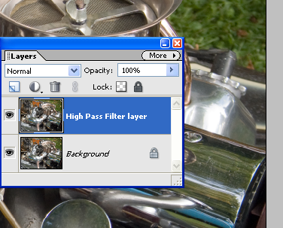USING A HIGH PASS FILTER FOR SHARPENING

- Make a copy ( Layer > Duplicate Layer) of the picture layer that you wish to sharpen.

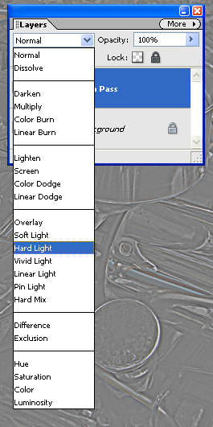
- Filter the copied layer with the High Pass filter (Filter>Other>High Pass) and press OK.
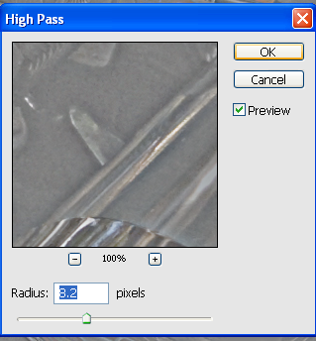

- With the filtered layer still selected switch the blend mode to Hard Light.

- This mode blends both the dark and light parts of the filtered layer with the picture layer, causing an increase in contrast.

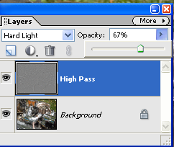
- Adjust the opacity of this layer to control the level of sharpening.

- Sharpening using this technique means that you can remove or adjust the strength of the effect layer by manipulating the filtered layer.

