Question and Answer - Producing PDI’s

Q1.What does the digital projector need?
Answer: An image that measures 1024 pixels by 768 pixels, with a resolution of 72 pixels per inch. This is the current optimum resolution that our projector works ‘best’.
Q2.Why does the PDI need a black background?
Answer: The lamp produces the PDI against a stark white background onto a white screen; this appears distracting and may detract from the quality of the PDI.
Q3. Does my PDI need to have a box/white or black line around the image?
Answer: It depends on the image and your vision of an image; adding a black line can create an obvious ‘stop’ for a picture helping the viewer focus on the picture; adding a white line can define a ‘dark’ image by creating a distinct boundary. Most judges appear to dislike broad and too dominant lines around an image.
Q4. What is the best format to save entries for a club competition?
Answer: It does not matter if the image is produced on a PC, MAC or other platform. Our club projector can show JPEGS. The current software that we use to show PDI’s shows JPEGS.
Q5.Does it help if PDI entries are numbered?
Answer: No, as the Windows operating system places all images starting with the digit 1together, then all the 2’s and so. When uploading to the PC ready to project the PDI filename has to be deleted and retyped.
Q6. Should I include my name in the filename title?
Answer: No, because the software currently used would display your name/filename on screen for everybody to read – this may affect a judge’s impartiality.
Q7.Should I use underscore_in_a_filename_to_allow_for_a_long_filename?
Answer:No. The use of the underscore used to be a feature of early Windows operating systems. Windows XP, Windows 7, etc can cope. When uploading to the PC ready to project all the underscores need to be deleted and sometimes titles retyped.
Q8. Should I use lower case or uppercase for the filenames?
Answer: Technically it does not matter at all. But based on experience with the current software used to project PDI’s UPPER CASE filenames are much easier to read on screen, so UPPER CASE FILENAMES are asked for.
Q9. Does it matter if I use a USB stick or CD to hand in PDI’s?
Answer: It makes no difference.
Q10. Should the filename match the title written on the entry form?
Answer: Yes, it should be the same.
Q11. Do I need to put my name and contact telephone number on the CD/USB stick entered?
Answer: Your name SHOULD be on the CD/USB entry and the form. A contact telephone number would be helpful, as occasionally a technical/entry form issue does arise.
The Projected Image
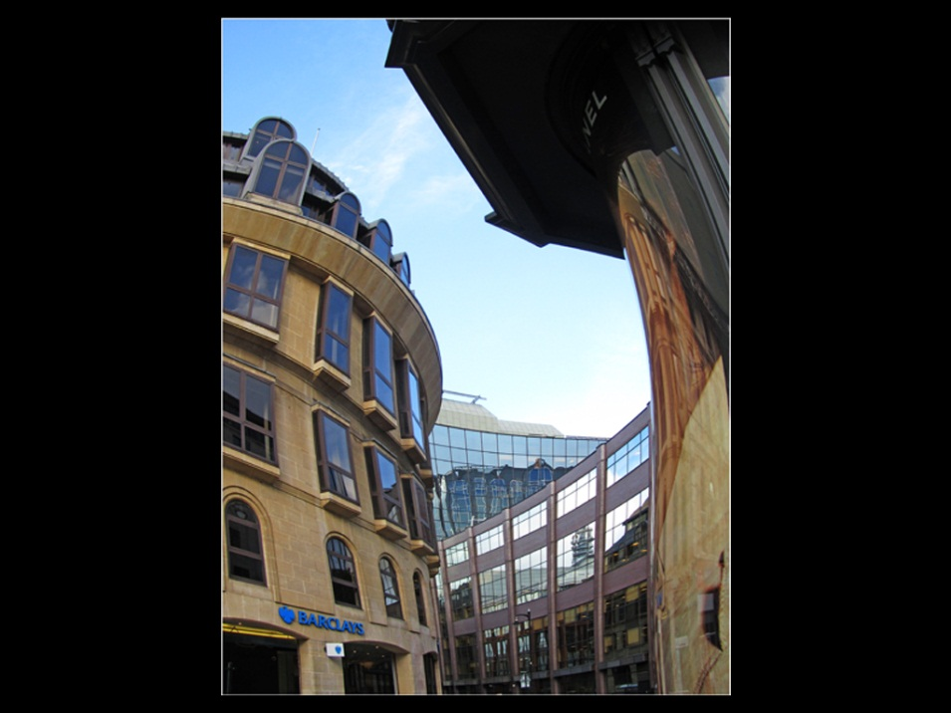
Thin border around the image
The filename for this image is
CURVED BANK.jpg
Sometimes the picture will measure 1024 x 768 pixels exactly and a black background is not needed.
The picture can sit anywhere or in any shape within the 1024 x 768 pixel black rectangle. A Letter box shape (wide and thin) is very popular.
Vertical picture sits within a horizontal 1024 x 768 pixel black rectangle.
Black background
768 pixels high
1024 pixels wide

