How to Make an Adjustment Layer
You can make a variety of adjustments to an image by using the Adjustments option on the layer, I’m also presuming that you are using one of the Photoshop products, CS or Elements, it differs in Lightroom I may add, other imaging software will be basically the same.

I would recommend that you make a duplicate of your image which will be then a copy, close down the original meaning duplicate the image first before proceeding any further so you are working on a copy, this will mean you will lose less data by working on a copy instead of the original, but you will lose some in the duplicate copy also I presume that the image is in jpeg form; there are two ways of not losing any pixel data, one is to convert the duplicate to a smart object layer, the other is a raw format of which I will discuss a little on as I would not like to confuse you at this moment in time.

There are a number of ways you can make a new layer:

PC: Control and J (keys)
1st Method
MAC: Command and J

This first method is the quickest (above), all tutors of Photoshop will tell you to use the short cut method.

2nd Using the layer panel on your right-hand side, pull and drag over the new layer icon, this looks like an envelope with a top edge turned down see blue arrow.

3rd Up to the top menu bar – Layer – click, then down to new adjustment layer; see red arrow.

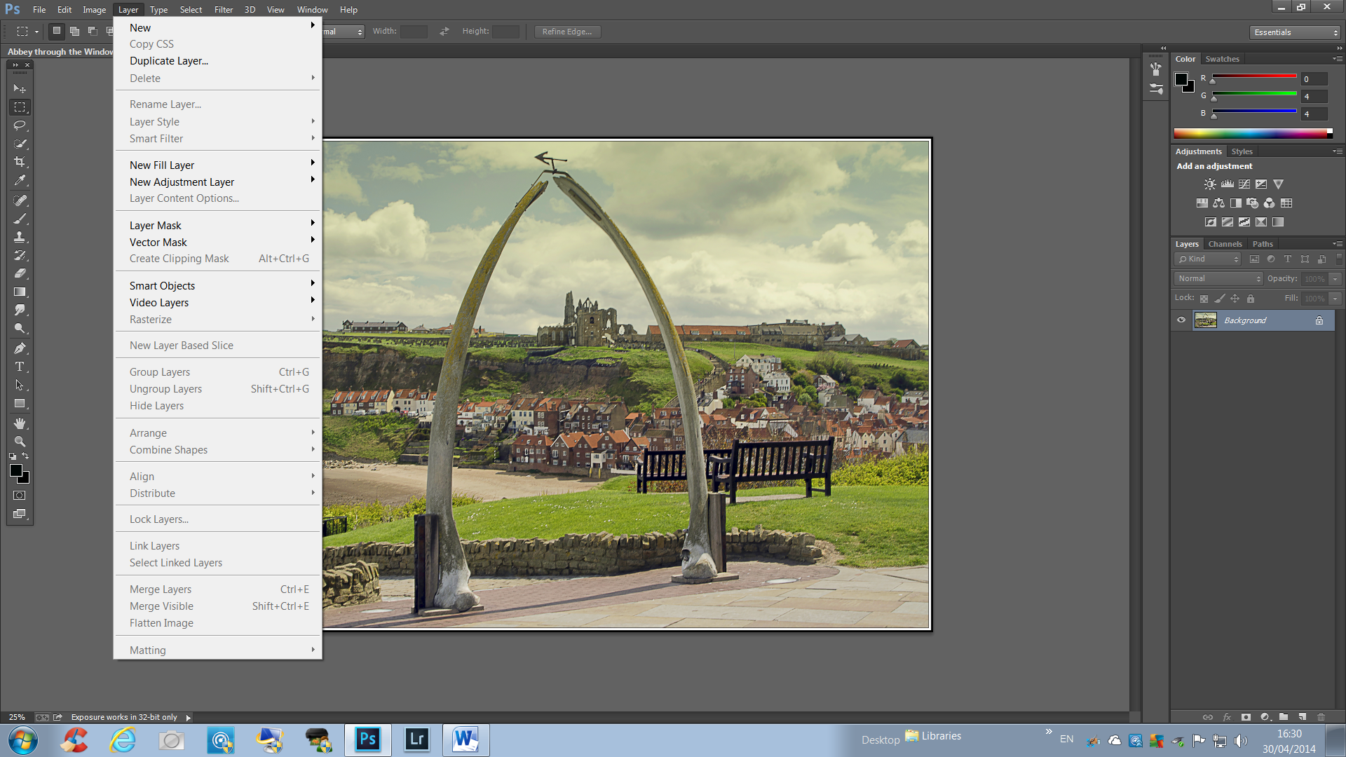
3rd method
2nd method

Simplyphil 30/04/2014

