Camera Basic’s

What is Composition?

What is composition from a Photographers stand point?

It is the way you frame your picture in the view finder or LCD/LED or screen – it is a visual process of
organizing elements of putting details of a scene into a balance.

Looking through a view finder virus seeing with your eye; this is a confusing statement by any means I’ll try to put it in an easy way. Your camera will see a different scene to the way your eye see’s the scene, why? Firstly your eye is 3d, the camera is 2d; secondly your eye has the ability to see all the scene in correct focus, thirdly your eye has the ability for a wide angle of vision also the ability to see more than one thing at a time, fourthly it is not fixed on one dedicated point un-like a camera.

What will good compositions have?

Good Composition: - the use of light, tone, shadows, lines and patterns. Subject and fore/back ground – balance –point of view leading you in or out – the rule of thirds – golden triangle – focal length – depth of field – camera position.

To get the best results firstly use a tripod where ever you can, this gives you a sound base to build on. Secondly, patience and knowledge plus experimentation with filters – apertures – speed – flash. This will all add to your knowledge of which you will build up with time; do I talk to myself when thinking the situation over! – Yes – am I going mad? No! But my imaginary friend – Gary does say- I’m a penny short of a shilling.

The rule of thirds.
You may be able to use grid lines in your camera; so when looking through your camera lens you should see two vertical and two horizontal lines giving you nine oblong squares, these lines are known as thirds, so please turn on your grid lines in camera it will aid you, if you have it, use it.
EXAMPLE – Sea Scape – tilt or frame your scene with the top first line lying on the horizon, that should give you one third of sky and two thirds covering the sea and beach.

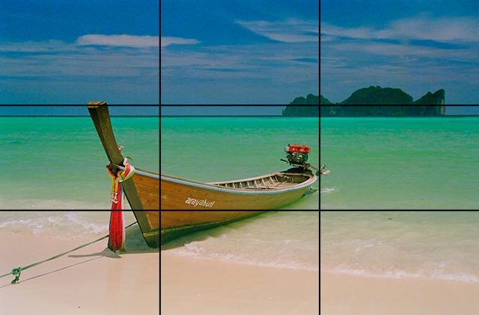

Next place your left or right vertical line on your subject either leading in or leading out.

Page one of two.(30/04/14)
The Golden Triangle

This is another aid to help your composition, just think of an isosceles triangle

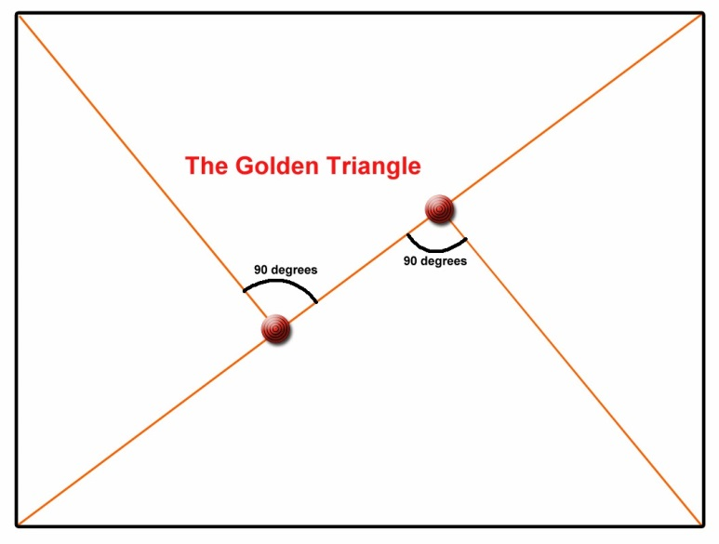

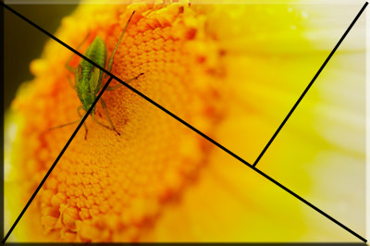

I can only hope that this article helps to aid your ability to raise your game plan.

Simplyphil

With acknowledgements to bing stock images.

Page two of two (30/04/14)

