A Smart Object/Layer.

You can convert a layer into a smart object, unlike a normal layer, the Adobe family, CS and Elements remembers the original composition, so you can resize and perform other operations without losing any data (degrading of quality).

To create a smart objet/layer.

First duplicate the image, select layer 1
- Click the layer that you want to convert to a smart object/layer.
- Click Layer. Blue arrow.
- Click Smart objects –red arrow
- Click Convert to smart layer – yellow arrow.
- You should have a smart layer.

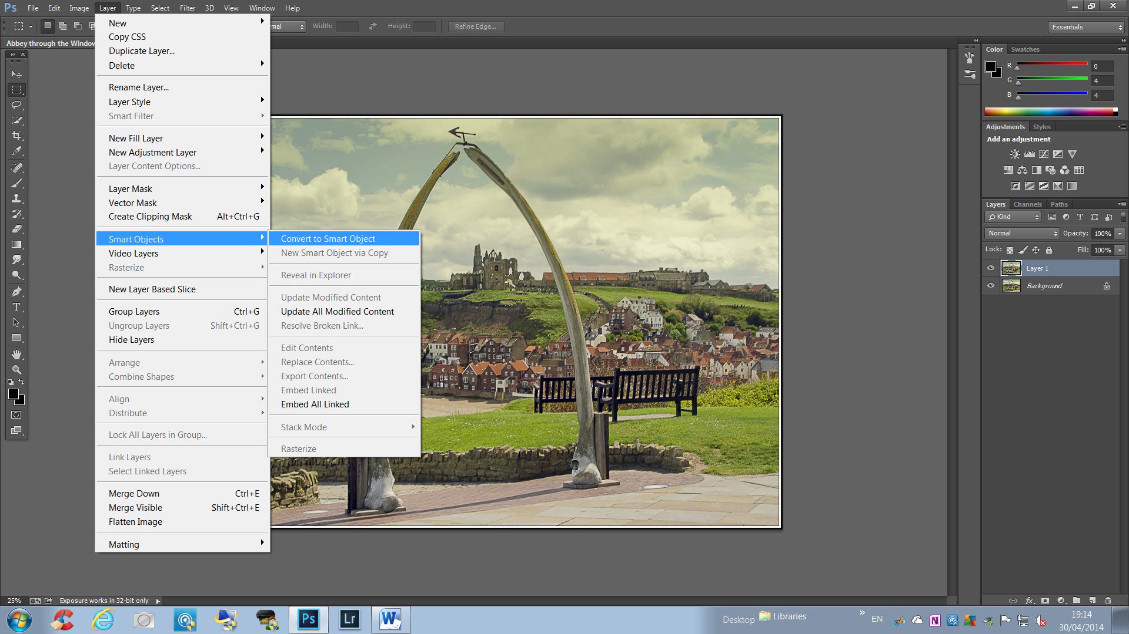
If you look at your layers panel, you should find that layer 1, now has a little box inside the thumb nail icon. (see blue arrow)
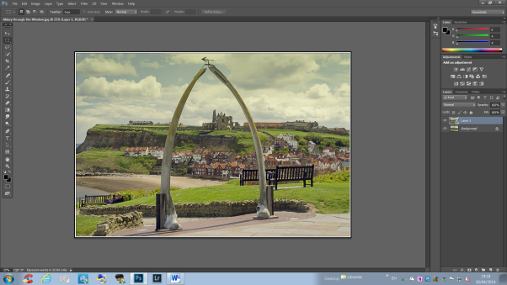

Now you can make adjustments and other layers without a loss of data.
Page 1 of 2
How do I convert a smart object/layer to a regular layer?

- Go to the top menu, select layer.
- Go down to smart objects.
- Click Rasterize.

This now converts the smart layer/object back into a regular layer, save as a psd, pse or flatten as a jpeg file; but if you flatten you have no way of knowing of the adjustments you have done.

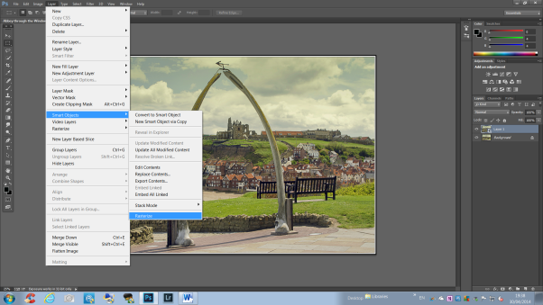

How to Duplicate a Smart Object

- Click a Smart Object in the LAYERS panel –Layer 1 thumb nail icon
- Click Layer
- Click Smart Objects
- Click New Smart Object via Copy
- Click the Move Tool, (on your left-hand side top of tools)
- Click and drag to view the new Smart Object

This is presuming that you are using Photoshop or Elements depending on Elements version number.

Simplyphil 30/04/14
Page 2 of 2

